Electronic supplementary information

SYnthesis and crystal structure of
a new rhomboid {Mn^{II}₂Mn^{III}₂} cluster based on
calix[4]arene and bathophenanthroline ligands

A. S. Ovsyannikov,*ª I. V. Strelnikova,^{a,b} A. A. Iova,^{b} D. R. Islamov,^{c}
P. V. Dorovatovskii,^{d} S. E. Solovieva,^{b} and I. S. Antipin^{b}

ª Arbuzov Institute of Organic and Physical Chemistry, FRC Kazan Scientific Center,
Russian Academy of Sciences, ul. Arbuzova 8, Kazan, Tatarstan, 420088 Russia
^{b} Kazan Federal University, ul. Kremlevskaya 18, Kazan, Tatarstan,420008 Russia
^{c} Laboratory for Structural Analysis of Biomacromolecules, FRC Kazan Scientific Center,
Russian Academy of Sciences, ul. Lobachevskogo 2/3, Kazan, Tatarstan,420111 Russia
^{d} National Research Centre "Kurchatov Institute",
pl. Akademika Kurchatova 1, Moscow, 123182 Russia

Single crystal X-ray diffraction study
Diffraction data for single-crystals of 3₂-Mn₄(bathophen)₂ were collected at 100 K on a Belok/XSA beamline (λ = 0.745 Å, φ-scans) of the Kurchatov Synchrotron Radiation Source (Moscow, Russian Federation) [S1, S2]. Diffraction patterns were collected using Mardtb goniometer equipped with Rayonix SX165 2D positional sensitive CCD detector at 100 K. In total, 450 frames were collected with oscillation range of 1°. The data were indexed, integrated and scaled; absorption correction was applied using the XDS program package [S3]. The structures were solved by direct methods with software SHELXT [S4]. The structural model was investigated and refined by using Olex2 software [S5] by a full-matrix least-squares method on F² with anisotropic displacement. Non-hydrogen atoms were refined anisotropically. All hydrogen atoms were placed in calculated positions and included in the refinement within the riding model with fixed isotropic displacement parameters Uiso(H) = 1.5Ueq(O), 1.2Ueq(N), and 1.2Ueq(C).
The crystallographic data and experimental details for 3₂-Mn₄(bathophen)₂ are presented in Table S1. CCDC 2383835 contains the supplementary crystallographic information for this paper. These data can be obtained free of charge from The Cambridge Crystallographic Data Centre via https://www.ccdc.cam.ac.uk.

Table S1. Crystallographic data and structure refinement parameters
for the coordination compound obtained
Compound name | 3₂-Mn₄(batophen)₂
Empirical formula | C₁₁₀H₈₆Mn₄N₆O₁₂, 2(CH₄O)
Formula weight, g·mol^{–1} | 1967.69
Wavelength, Å | 0.745
Temperature | 100(1)
Crystal system | triclinic
Space group | P-1
a, Å | 11.700(2)
b, Å | 15.170(3)
c, Å | 15.380(3)
α,° | 108.65(3)
β,° | 107.11(3)
γ,° | 103.43(3)
V, Ǻ³ | 2305.8(10)
Z/Z´ | 1/0.5
ρ_{calc} g,cm³ | 1.417
μ,cm^{–1} | 0.684
F(000) | 1020.0
Crystal size, mm³ | 0.3 × 0.2 × 0.2
2θ range for data collection, ° | 5.076 ≤ 2θ ≤ 62.1
Index ranges | –16 ≤ h ≤ 16,  –20 ≤ k ≤ 21,  –21 ≤ l ≤ 21
Reflections collected/independ. | 57179/12278
R_{int} | 0.0385
Completeness to θ_{max}/% | 95.7
Data/restraints/parameters | 12278/0/617
Goodness-of-fit on F² | 1.031
Final R indexes [I > 2σ (I)] R₁/wR₂ | 0.0415/0.1056
Final R indexes [all data]  R₁/wR₂ | 0.0470/0.1090
ρ_{max}/ρ_{min}, eÅ^{–3} | 0.71/–0.54

Table S2. Coordination bond angles for Mn ions of 3₂-Mn₄(bathophen)₂ (º)
O_{X}–Mn(1)–O_{Y} | 81.71(6)  98.71(6)  178.89(5)  89.14(6)  99.40(6)  81.38(6)
O_{X}–Mn(1)–N_{x} | 85.78(6)  92.42(6)  166.60(6)  96.69(6)  97.53(6)  168.09(6)  93.11(6)  87.41(6)
N_{X}–Mn(1)–N_{Y} | 78.99(6)
O_{X}–Mn(2)–O_{Y} | 92.09(5)  97.18(5)  91.67(5)  87.22(5)  162.64(5)  92.46(6)  175.27(6)  89.50(6)  97.93(5)  89.92(6)  175.11(6)  96.52(5)  87.82(6)  77.73(5)  78.77(5)

Table S3. CShM deviation values calculated by SHAPE program for Mn atoms in 3₂-Mn₄(bathophen)₂
Complex name | Mn | HP-6 | PPY-6 | OC-6 | TPR-6 | JPPY-6
3₂-Mn₄(dmf)₄ | Mn(1) | 29.386 | 24.558 | 1.319 | 13.669 | 27.791
3₂-Mn₄(dmf)₄ | Mn(2) | 31.288 | 26.303 | 1.329 | 14.137 | 29.970

Label | Symmetry | Shape
HP-6 | D_{6h} | Hexagon
PPY-6 | C_{5v} | Pentagonal pyramid
OC-6 | O_{h} | Octahedron
TPR-6 | D_{3h} | Trigonal prism
JPPY-6 | C_{5v} | Johnson pentagonal pyramid (J2)

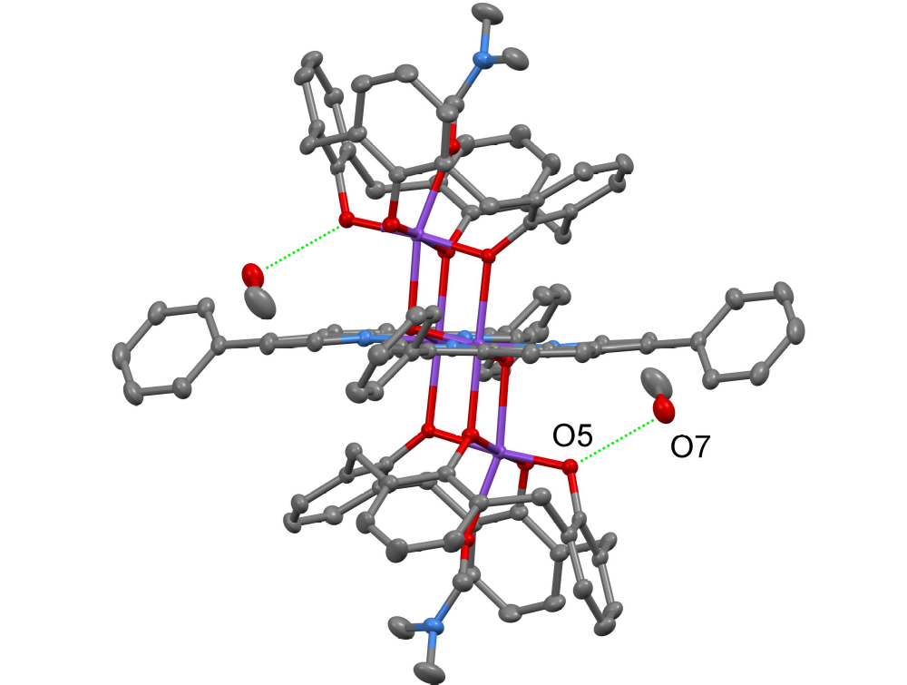
Figure S1. H-bonding between the solvate MeOH molecules
with 3₂-Mn₄(bathophen)₂ cluster molecule within the crystal packing.

References
S1. V. A. Lazarenko, P. V. Dorovatovskii, Y. V. Zubavichus, A. S. Burlov, Y. V. Koshchienko, V. G. Vlasenko, V. N. Khrustalev, Crystals, 2017, 7, 325. DOI: 10.3390/cryst7110325
S2. R. D. Svetogorov, P. V. Dorovatovskii, V. A. Lazarenko, Cryst. Res. Technol., 2020, 55, 1900184. DOI: 10.1002/crat.201900184
S3. W. Kabsch, Acta Crystallogr., Sect. D: Biol. Crystallogr., 2010, D66, 125–132. DOI: 10.1107/S0907444909047337
S4. G. M. Sheldrick, Acta Crystallogr. A: Found. Adv., 2015, 71, 3–8. DOI: 10.1107/S2053273314026370
S5. O. V. Dolomanov, L. J. Bourhis, R.J. Gildea, J. A. K. Howard, H. J. Puschmann, J. Appl. Crystallogr., 2009, 42, 339–341. DOI: 10.1107/S0021889808042726

